

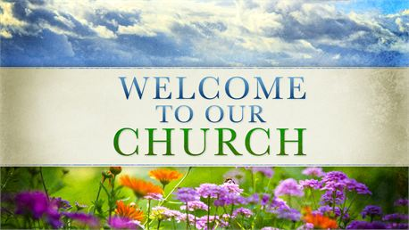

**Howard-Miami Mennonite Church**

**3976 E 1400 S – Kokomo, IN 46901 – 765.395.7509**

**Sunday, Oct 19, 2025**

***Love as Christ Loves***

**Call to Worship:** Jackie Varnell

**Songs:** WB 71 Joyful, Joyful, We Adore Thee

Love the Lord Your God

**Announcements & Offering:** Jackie Varnell

**Song:** Great Are You Lord

Holy Forever

**Prayer Time:**

**Children’s Time:** Pastor Matt

**Children are dismissed for Children’s Church**

K-5 goes to the Jesus and Me: (JAM Basement)

**Scripture**: Acts 6:8-7:60

**Next Week’s Scripture:**

**Message:** First Martyr

**Next Week’s Message:**

**Song**: Faithful Men

**Benediction**: Pastor Matt Stewart

**Prayer and Praise Request**

**Pray for those unable to attend**: Alma Bontrager, Rosalyn Beachy, Clara Chism, Pauline Rhine, Joyce Dittfield, & Carson and Verba Engel

**Pray for Health and Other Concerns**: Traveling families- Prayers for safe travels, **Anita Bontrager** for healing, **Terri Bond** for healing for her broken arm, **Carolyn Myers** on her leukemia journey, **Caylee Camden** for her high-risk pregnancy, **Lauren Bond** for healing for stress, **Melody Swart** and her family on her breast cancer journey, **Grace Howe** and her family that she will feel God’s presence in her current struggles, **Dwain Varnell** and his family as he continues to battle renal failure

**Announcements**

CMT is looking for fun and creative volunteers to do a fish-themed table at our Fall Harvest Party on **Friday, October 31st from 6–8 p.m. Please sign up at the information table if you would like to help! Plan on decorating your own table and supplying your own candy. Talk to** Cindy Miller, Mary Birkey, Pastor Matt, Brooke Mast, or Austin Moore if you have any questions.

Please join us as we celebrate Cindy & Larry Miller’s 50th Wedding Anniversary, Sunday, November 16th, from 2-4 p.m.in the Fellowship Hall. All are welcome, no gifts necessary

There will be no Pavilion Night for October.

November's Communion will be held on the 9th during Sunday service

Fall Reports for the Fall Business Meeting need to be turned in no later than Thursday, Nov. 6th

Representatives from the following Committees can turn reports into the black church mailbox next to the church office

CMT, Trustees, Women’s Council, Women’s Sewing, & Flooring Committee

**What’s Coming Up…**.

Oct 28: Buddy Bags @ 5:30 p.m.

Oct 29: Budget Meeting @ 6 p.m.

Oct 31: Fall Harvest Party 6-8 p.m.

Nov. 1: Church Reserved 10-4 p.m.

Nov. 6: Women’s Sewing 9-3 p.m.

Nov. 8: Women’s Coffee @ 9 a.m.

Nov 9: Fall Business Meeting and Carry In

**Offering and Attendance**

**Attendance Last Week:**76

**Offering Last Week**: $ 2,216.81

**Average Weekly Offering**: $3,418.65

**Average Weekly Offering Needed**: $3,555.77

**Offering Year–to–Date:** $140,164.45

**Office Hours:**

**Pastor Matt Stewart**

**Mon – Fri**

**9 a.m. to 12 p.m.**

**Any other times, please contact Pastor Matt for an appointment**

**Cell: 585.509.4804**

[**pastormatt@howardmiami.org**](mailto:pastormatt@howardmiami.org)

**Office**

**Tuesday & Thursday**

**8:30 a.m. – 12:30 p.m.**

**Church Email:** [**office@howardmiami.org**](mailto:office@howardmiami.org)

